**21. Data Analytics for Guna.xlsx data with visualization of graph**

**Aim :**

To write an R Program perform data analysis and visualization in **R** using a Guna dataset

**Algorithm :**

**Step 1:** Start the process to find prime numbers below a given number.

**Step 2:** Use setwd() to specify the folder containing the dataset, Confirm the path using getwd()

**Step 3:** Use read.csv() to load the CSV file into a dataframe (here, guna).

**Step 4:** Use head() to display the first few rows. Use summary() to get descriptive statistics of all columns.

**Step 5:** Plot histograms for numeric attributes (e.g., Apptitude, Attitude) to visualize frequency distribution. Use hist() with parameters like breaks, col, border.

**Step 6:** Generate bar plots for categorical data (e.g., Gender, gunas) using barplot(table(...)).

**Step 7:** Use boxplot() to show the spread, quartiles, and outliers of numeric variables (Apptitude, Attitude).

**Step 8:** Use plot() to represent the relationship between two numeric variables (Apptitude vs Attitude).

**Step 9:** Create a frequency table using table().Convert to data.frame and use pie() to visualize category proportions (e.g., gunas).

**Step 10:** Stop the program

**Program :**

getwd()

setwd("C:/Users/MCA-007/Documents/R prog")

guna = read.csv("guna.csv")

head(guna)

summary(guna)

hist(table(guna$Apptitude),xlab = "Aptitude",col = "Green",border = "red",xlim = c(0,100),ylim = c(0,30),breaks = 5)

#bar plot

barplot(table(guna$gunas),col = "green")

barplot(table(guna$Attitude),col = "green")

barplot(table(guna$Gender),col = "green")

barplot(table(guna$Apptitude),col = "green")

#box plot

boxplot(guna$Apptitude,col = c("green"))

boxplot(guna$Attitude,col = c("green"))

hist(table(guna$Apptitude),xlab = "Aptitude",col = "green",border = "red",xlim = c(0,100),ylim = c(0,30),breaks = 5)

hist(table(guna$gunas),xlab = "gunas",col = "green",border = "red",xlim = c(0,100),ylim = c(0,30),breaks = 5)

hist(table(guna$Attitude),xlab = "Attitude",col = "green",border = "red",xlim = c(0,100),ylim = c(0,30),breaks = 10)

#Scatter plot

plot(x=guna$Apptitude,y=guna$Attitude,xlab = "Apptitude",ylab = "Attitude",main = "Apptitude vs Attitude",

col=c("red","green"))

legend("bottomright",pch = 5,col = c("red","green"),legend = c("Aptitude","Attitude"))

#pie chart

d=as.data.frame(table(guna$gunas))

print(d)

pie(d$Freq,c("Rajasic","Sattvic","Tamasic"))

pie(d$Freq,d$Var1)

**OUTPUT:**

**Bar Plot**

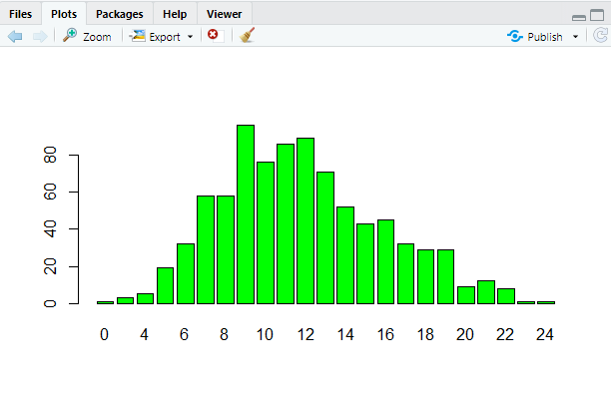

**Box Plot**

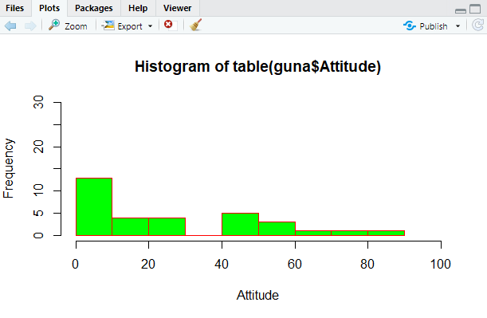

**Scatter Plot**

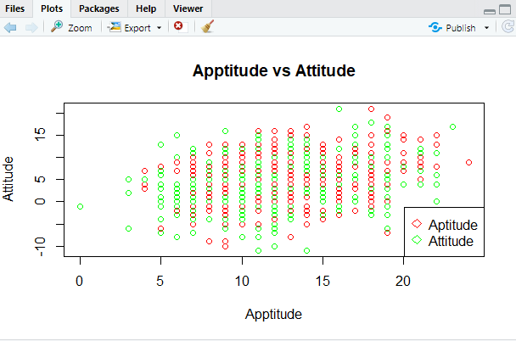

**Pie Chart**

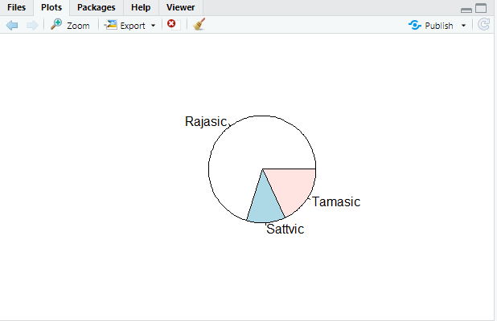

**RESULT:**

Thus, our program has been successfully saved and executed.